**Charlize Theron**

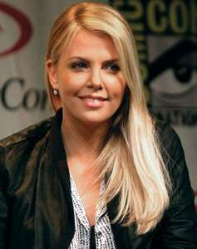

Charlize Theron holds dual citizenship of US and South Africa. She was born in the City of Benoni in South Africa on August 7, 1975 to an Afrikaner family with a mixed ancestry of Dutch French and German. Charlize’s native language is Afrikaans but she speaks English fluently.

As a teenager she was deeply traumatized when on the 21st of June 1991, she witnessed her mother Gerda Jacoba Aletta (née Maritz) shoot and killed her father Charles Jacobus Theron as a result of a perceived threat of attack from the drunken father. The mother was not charged because it was legally classified as self defence.

Charlize grew up on a farm but was, at an early age, very interested in ballet was therefore enrolled by her mother into a specialized boarding school for arts at the age of 13 to develop her ballet skills.

At the age of 16 she moved on to Milan in Italy where she secured a job as a model and at the age of 18 she proceeded to New York to study ballet at the Joffrey Ballet School but continued to work in her spare time as a model. However, a knee injury would put an end to her desire to be a ballet dancer.

She moved on to Hollywood and after several attempts at securing an acting role eventually landing a part in *2 Days in the Valley (1996);* a part which was to expose her acting ability to Hollywood and increase her chances of securing better roles.

Her first big break was in 1997 when she starred in *The Devil’s Advocate.* Her role in *The Devil’s Advocate* opened up a career that would immediately see her taking major roles in *Mighty Joe Young* (1998), *Celebrity (*1998), The *Cider House Rules* (1999), and *The Italian Job* (2003) respectively.



By 2004 Charlize had fully matured to become a versatile actress appearing in two movies *The Life and Death of Peter Sellers* and *Head in the Clouds* in the same year. She was now fully ready to start raking in awards and she did it in grand style in the movie North *Country* in which she earned an Academy Award nomination for best actress for her performance.

With her blonde hair and green eyes and statuesque model-like figure, she was able to fit into a diversity of roles ranging from drama to super hero movies. She played leading roles in *In the Valley of Elah* (2007), *Hancock* (2008), and *The Road* (2009). Her performance in the role of a serial killer in the movie *Monster* was phenomenal earning her the Academy Award, Silver Bear, Golden Globe Award, and Screen Actors Guild Award for Best Actress in one go.

Her extraordinary talents also manifested in the movie *Young Adult* (2011) leading to a Golden Globe Award. She also displayed an awesome acting talent on the big screen when she appeared in 2012 as the evil queen in the dark fairytale drama presentation Snow *White and the Huntsman* (2012) and its sequel, *The Huntsman:* *Winter’s War* (2016).

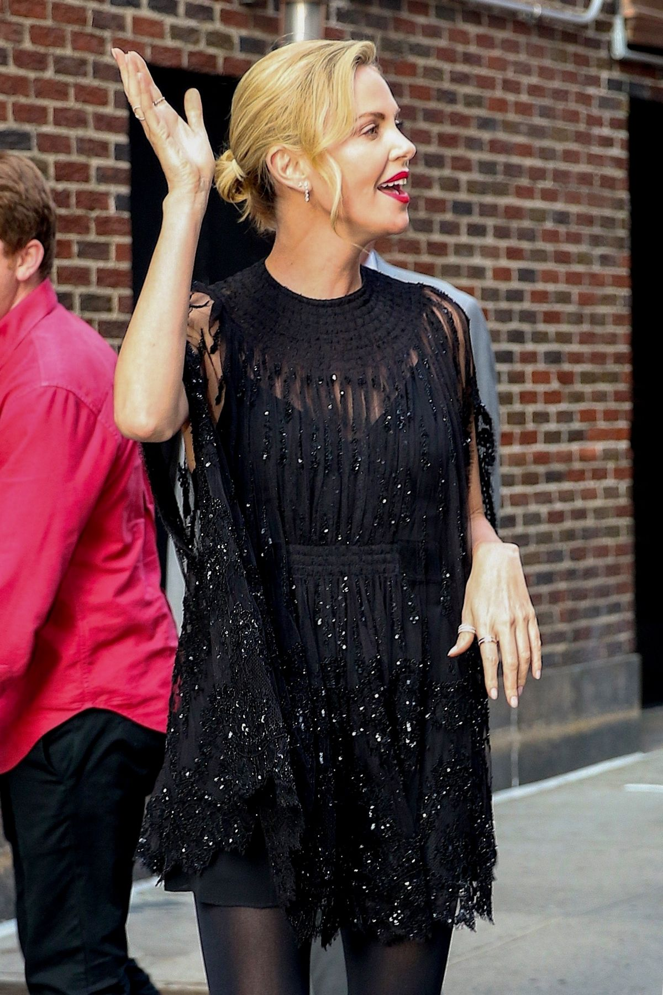

Her talents and her good looks have been instrumental in and out of the stage attracting the attention of the media, show business and advertisement industries. She was ranked as one of the "most desirable" women on *Ask men's top 99* "most desirable" women of 2013 and *What Is Sexy List* named her the “Sexiest Actress” in Hollywood in 2012 paving a way for her to secure an endorsement contract worth $2million per annum with Dior for their "J'Adore" fragrance, as well as $2.5 million per year for another contract endorsing Swiss watchmaker *Raymond Weil*. The United Nations appointed her UN Messenger of Peace.



Charlize Theron did not restrict herself to acting. She dabbled into producing in 2000 because she believed she has creative and innovative talents. She formed her own production company known as Denver and Delilah Productions. With her at helms of affair the company has produced several films, some of which Charlize played the starring role. Examples include *The Burning Plain* (2008) and *Dark* *Places* (2015).



**Charlize and her Mother Gerda**

Charlie is a workaholic. No surprise that she resorts to Marijuana. She revealed that her mother Gerda is her supplier of Marijuana and together they partake in the drug to help them overcome sleeping problems.

Charlize is much attached to her mother, even though she has two adopted children of her own. This may be because she brought her up as a single parent and because her mom opened up the opportunities for her in her early life. She has had two serious romantic relationships. The first one with Irish actor Stuart Townsend with whom she lived with from 2002 to 2010 when they split. The second relationship began in 2013 with actor Sean Penn but the two went their separate ways in June 2015.